43.63: 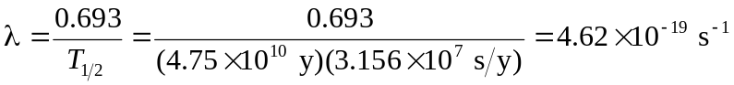
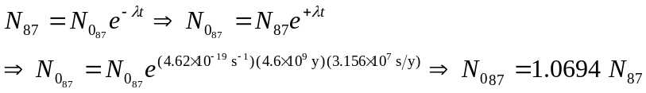
But we also know that 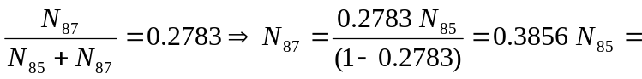
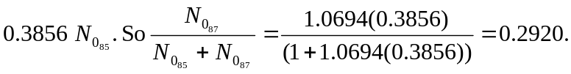
So the original percentage of 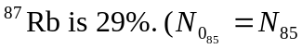 since it doesn’t decay.)

